AIRC South West Region Regional Training Day
(Supported by AIRC Training Bursary)
at Skevanish Equestrian Centre
On Sunday 21st & Monday 22nd April 2019
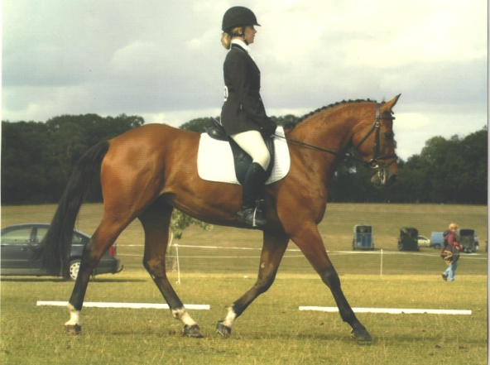
Cross Country Training Cost €20 each, class lesson will be approximately 1.5 hours long.
Training will be provided by the following:
- Ellen Beardsley BHS Instructor & HSI Coach
- Vanessa O Sullivan BHS Instructor & former 2* International Eventer
Dressage Training: Privates €30 Semi Privates €20
Training Provided by:
Shota Niikura BHS I Instructor & HSI Level 2 Coach
Frank O Sullivan BHS Instructor
Don’t forget your AIRC card and also correct helmet and back protector for XC.
Entries on plain sailing https://www.itsplainsailing.com/club/swrc
or to southwestrcevent@gmail.
Times will be posted on Friday 19th April on the Southwest Facebook page
Enquires to Kieran O Sullivan 0214775476 southwestrcevent@gmail.com

