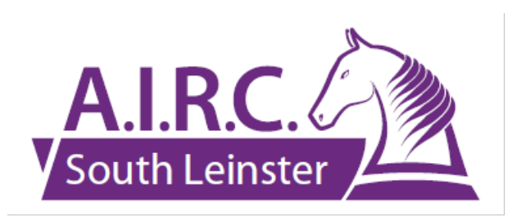
SOUTH LEINSTER REGION, AIRC

are pleased to announce Three Training Clinics
(with the support of the AIRC Training Bursary)
Thursdays 11/18 June

Dressage Clinics with Gerald Bloomer and Ruth Hayes, HSI Level 3 Coaches (Dressage) in Brennanstown Riding School

Tuesdays 16/23 June, Thursdays 18/25 June
Showjumping Clinics with Andrew Byrne (Tuesdays) and Pam Walshe (Thursdays) in Boswell Equestrian

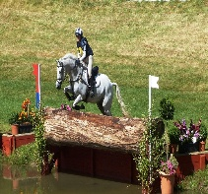
Thursdays 9/16 July
Cross Country Clinic with Louise Bloomer HSI Level 3 Coach(Eventing)in Bourkes, Monastery, Enniskerry

!!This is a great opportunity to avail of some really top class training at a very subsidised rate !!!
Details as follows:
Participants will be organised into small groups of 3 (Dressage) and 4 (Showjumping/XC), split according to grade and will receive 2 lessons each

Total Cost (2 lessons):
Dressage Clinic €60.00 Showjumping Clinic €50.00 XC Clinic €50.00

Bookings through https://itsplainsailing.com/org/aslr (opening on 25 May)
No of Slots: 15 (Dr), 16 (SJ), 8 (XC) so get your bookings in quickly!!
Note – a member may only ride one horse in each clinic
Enquiries Hilary 086 8239515 Jane 087 2626936 Patricia 087 2995388

