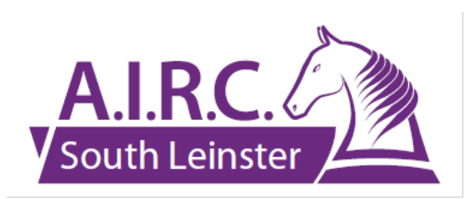

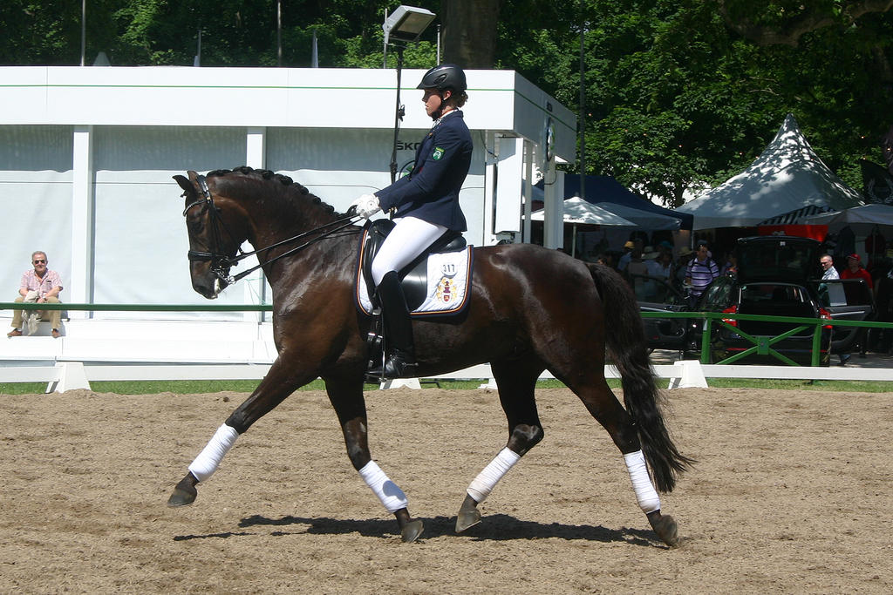

SOUTH LEINSTER REGION, AIRC
Summer Dressage League 2024
at Marlton Stud
(by kind permission of the Delahoyde Family)

Dates: Sunday 23 June, Sunday 7 July
Sunday 14 July (Regional Qualifier) ***
Saturday 20 July (Final)

List of Classes & Tests:
RCP1 Standard – AIRC Preliminary 5 (2020)
RCP2 Standard – AIRC Preliminary 7 (2020)
RCP3 Standard – DIP15 (2012)
RC N Standard – DIN23 (2012)
RCE Standard – DIE50 (2013)
RCM Standard – AIRC M72 (2015)
RCP1 Open – AIRC6 (2020)
RCP2 Open – DIP5A(2021) Short
RCP3 Open – AIRC15 (2020)
RCN Open – AIRC23 (2020)
RCE Open – DIE51 (2013)
RCM Open – DI M65 (2021)

*** Qualification for the Dressage Championships on 14 July will be determined by combining the scores from both the Standard and Open classes in each grade which means those wishing for qualification need to enter both these classes on that day.
Clubs please note that teams need to be entered using the official AIRC entry form available at this link https:/airc.ie/dressage2024/ and sent to the Regional Secretary at machughh@gmail.com

Entry Fee: €18.00 and to be made through Itsplainsailing.com/org/aslr (entries for 23 June will open on 10 June and close on 20 June) and times available on Hollybrook facebook Friday evening preceeding each competition)

Enquiries to Hilary on 086 8239515

